**United States Department of Agriculture**

Food and Nutrition Service

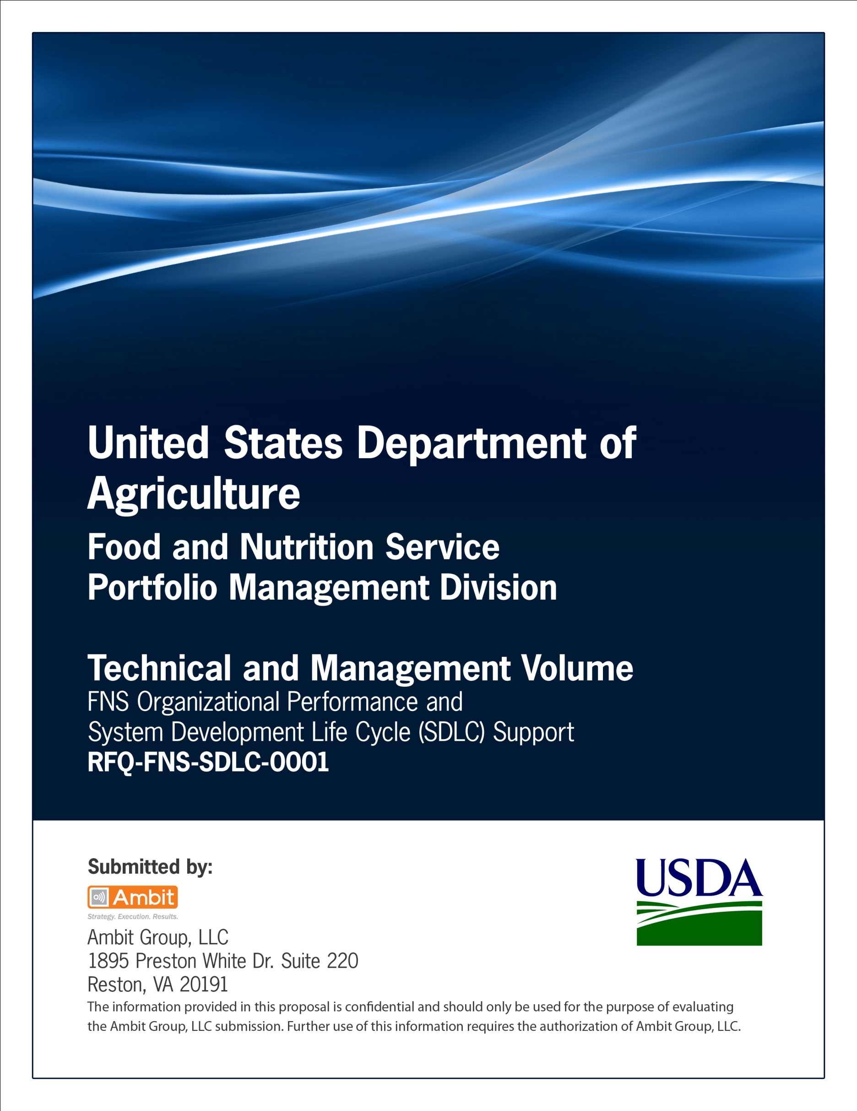

**FNS Office of Information Technology**

**Portfolio Management Division (PMD)**

**FNS Business Case 758 Template**

**(Business Case Summary)**

**for**

**[Project or System Name]**

**Version 1.1**

September 09, 2013

**Revision History**

|  |  |  |  |
| --- | --- | --- | --- |
| **Version** | **Date** | **Author** | **Change Description** |
| 1.0 | 03-08-2013 | IT Governance Branch (ITGB) | Created the document. |
| 1.1 | 09-09-2013 | IT Governance Branch (ITGB) | Re-formatted the document. |
| 1.2 |  |  |  |
| 1.3 |  |  |  |

**Contact Information**

|  |  |
| --- | --- |
| **Area of Concern** | **Contact Person** |
| IT Governance Lead | Kevin Russ |
| SDLC Coordinator | Syed Jaffery |
| ITIRB Coordinator | Sunny Dilawari |
| Portfolio Management Division Director, Chief Portfolio Officer | Jacqueline Butler |
| Program Management Branch Chief | Allison Willcox |

Contents

FNS BUSINESS CASE: FNS758 4

Approvals/Signatures 5

# FNS BUSINESS CASE: FNS758

|  |
| --- |
| **Value Proposition:**  Strategic:  Financial:  Operational:  Technical: |

|  |
| --- |
| **FNCS As-Is Overview:** |

|  |
| --- |
| **FNCS To-Be Overview:** |

|  |
| --- |
| **Cost Estimate:**  Initial Cost:  Avg. Annual Cost:  5-year Cost:  Number of Government FTE’s (Full Time Equivalent): |

|  |
| --- |
| **High-Level Timeline & Milestone:** |

|  |
| --- |
| **Risks & Dependencies:** |

**FNS-758 (10-06) Electronic Form Version Designed in Adobe 7.1 version SBU Page 1 of 1**

# Approvals/Signatures

The undersigned acknowledge that they have reviewed the [name of document] document and agree with the information presented within this document. Changes to this document will be coordinated with, and approved by, the undersigned, or their designated representatives.

|  |  |  |  |
| --- | --- | --- | --- |
| Signature: |  | Date: |  |
| Print Name: |  |  |  |
| Title: |  |  |  |
| Role: | [Project or System Name] Project Manager |  |  |
|  |  |  |  |
| Signature: |  | Date: |  |
| Print Name: |  |  |  |
| Title: |  |  |  |
| Role: | [Project or System Name] Business Owner |  |  |
|  |  |  |  |
| Signature: |  | Date: |  |
| Print Name: |  |  |  |
| Title: |  |  |  |
| Role: | Organization’s Approving Authority |  |  |